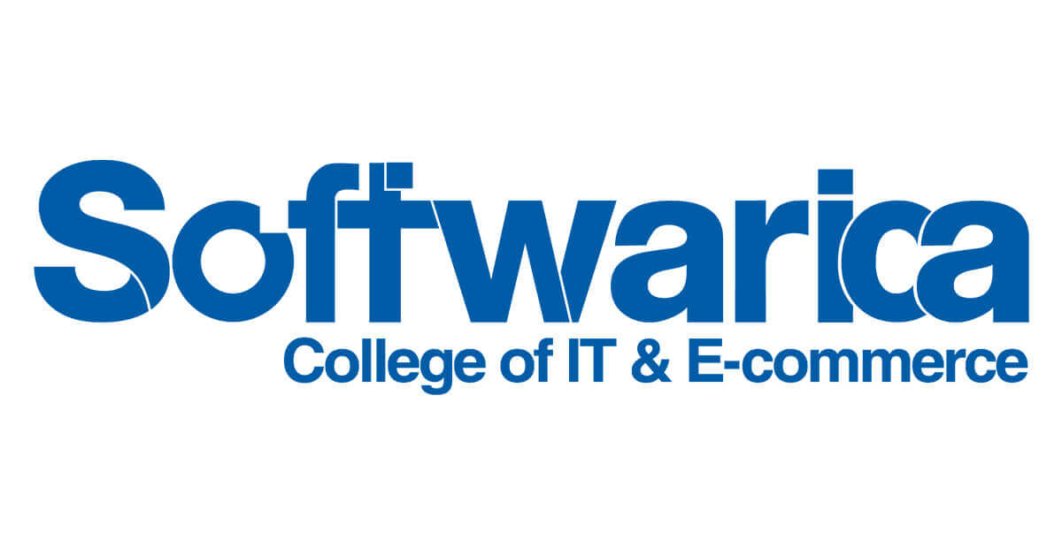

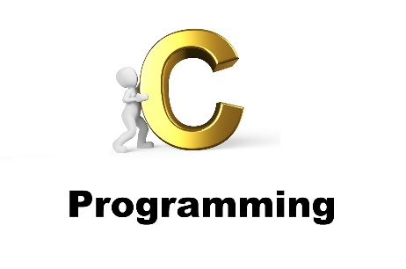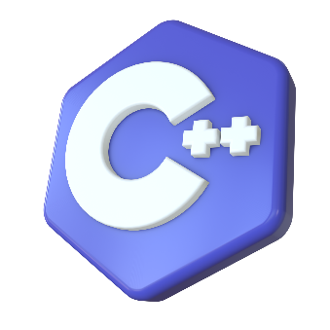

~ Abhishek Adhikari

**Aug**

Submitted to:

Shrawan Thakur

Project Documentation: C Programming Exercises 2

1. Introduction 2

2. Programs 2

2.1 Check if a Number is Even or Odd 2

Code: 2

Output: 3

2.2 Maximum of Three Numbers 3

Code: 3

Output: 4

2.3 Reverse a String 4

Code: 4

Output: 5

2.4 Factorial of a Number Using Recursion 5

Code: 5

Output: 6

2.5 Two Numbers Using the Euclidean Algorithm 6

Code: 6

Output: 7

2.6 Check if a String is a Palindrome 7

Code: 7

Output: 8

3. Conclusion 8

4. References 8

# Project Documentation: C Programming Exercises

## Introduction

This document provides a comprehensive overview of various C programming exercises. Each section includes the purpose of the program, the code, and instructions for compiling and running the program.

## Programs

### 2.1 Check if a Number is Even or Odd

#### Code:

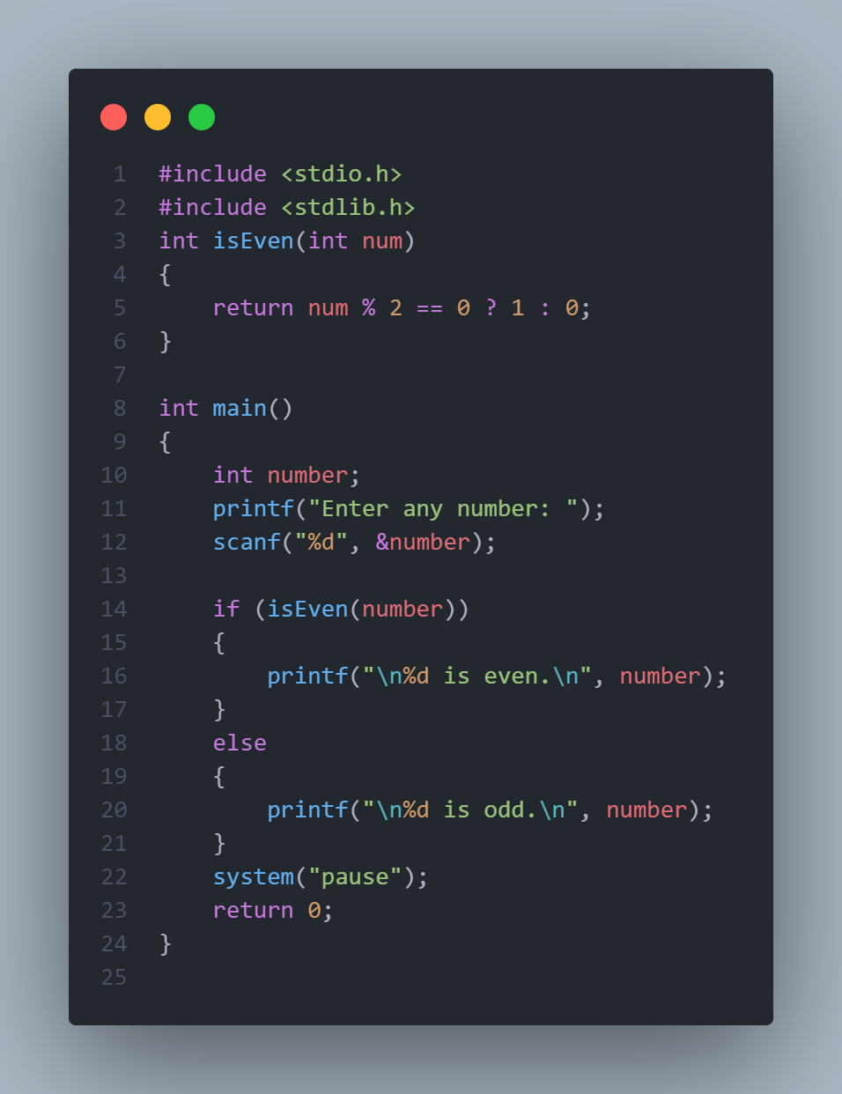

#### Output:

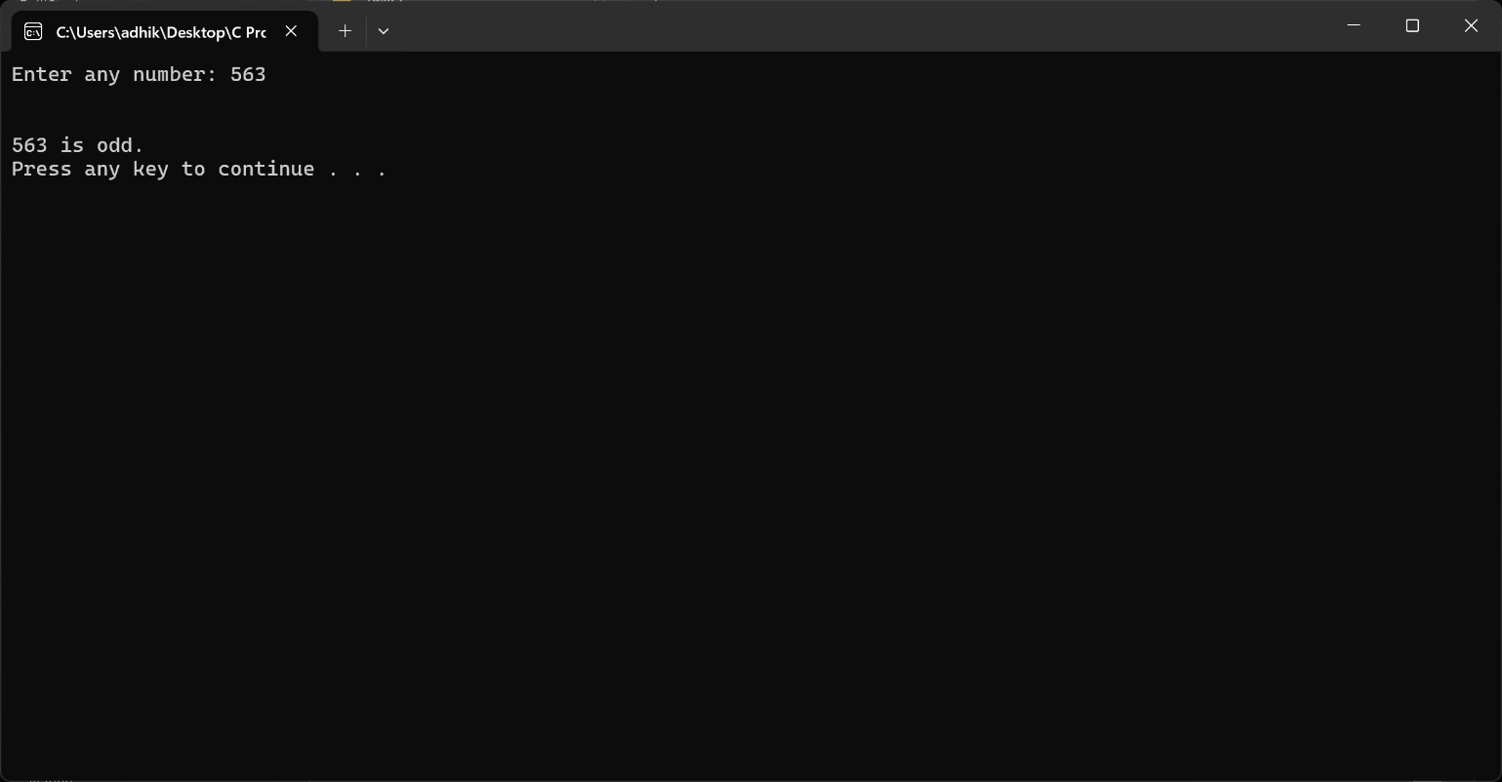

### 2.2 Maximum of Three Numbers

#### Code:

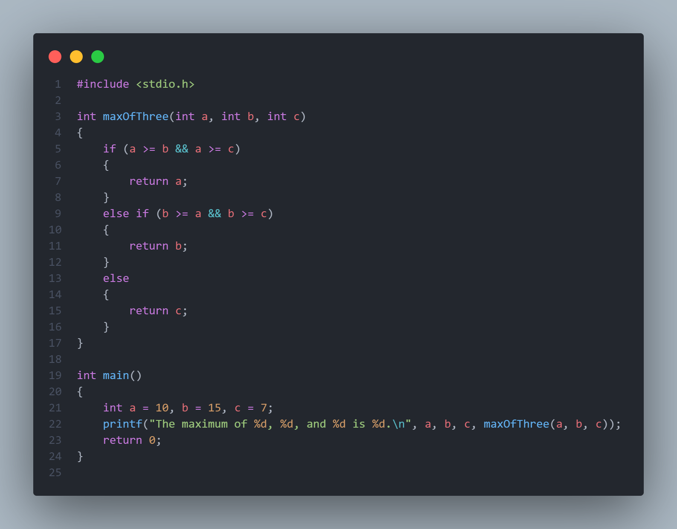

#### Output:

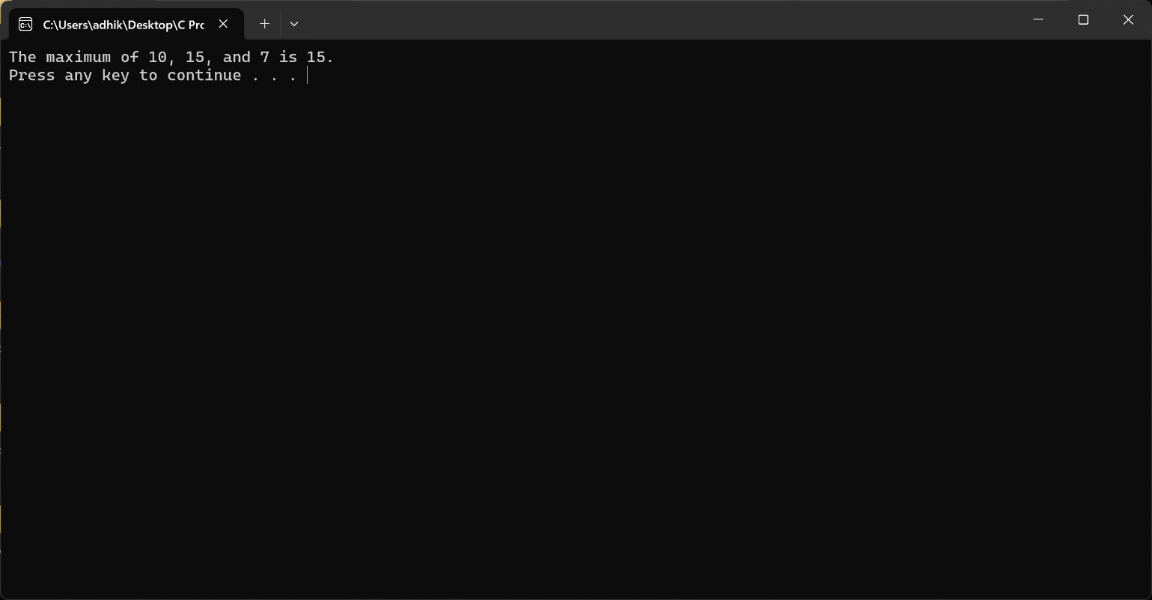

### 2.3 Reverse a String

#### Code:

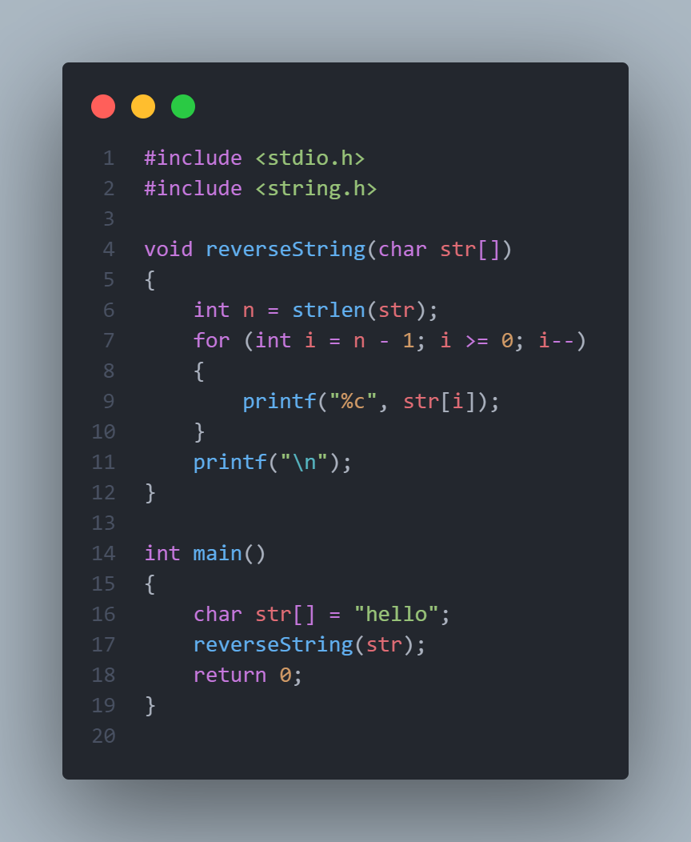

#### Output:

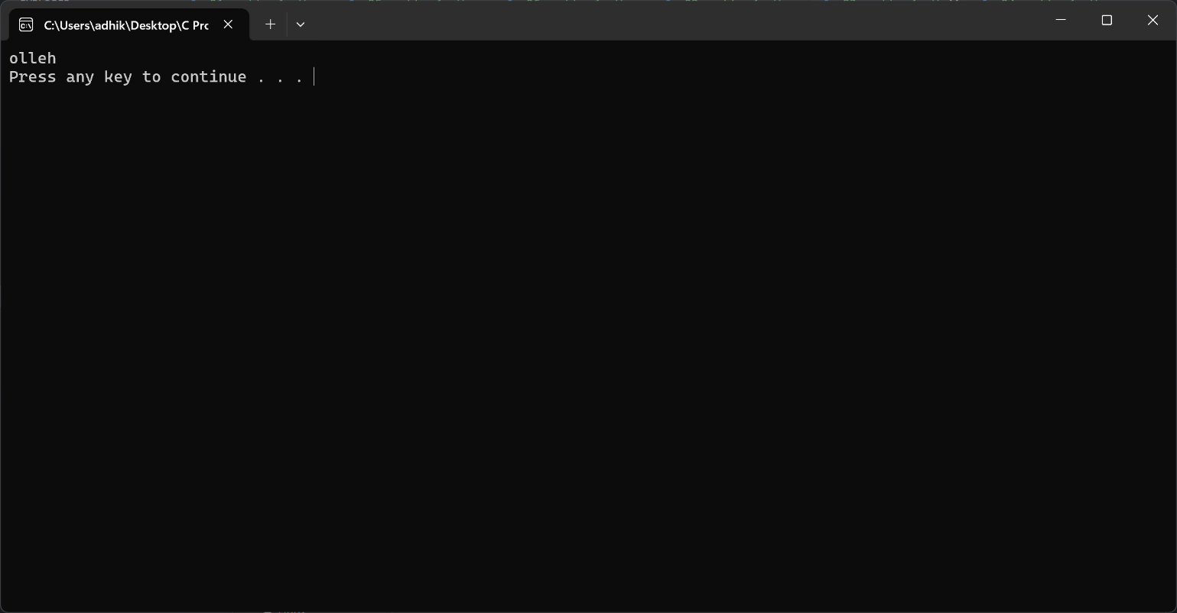

### 2.4 Factorial of a Number Using Recursion

#### Code:

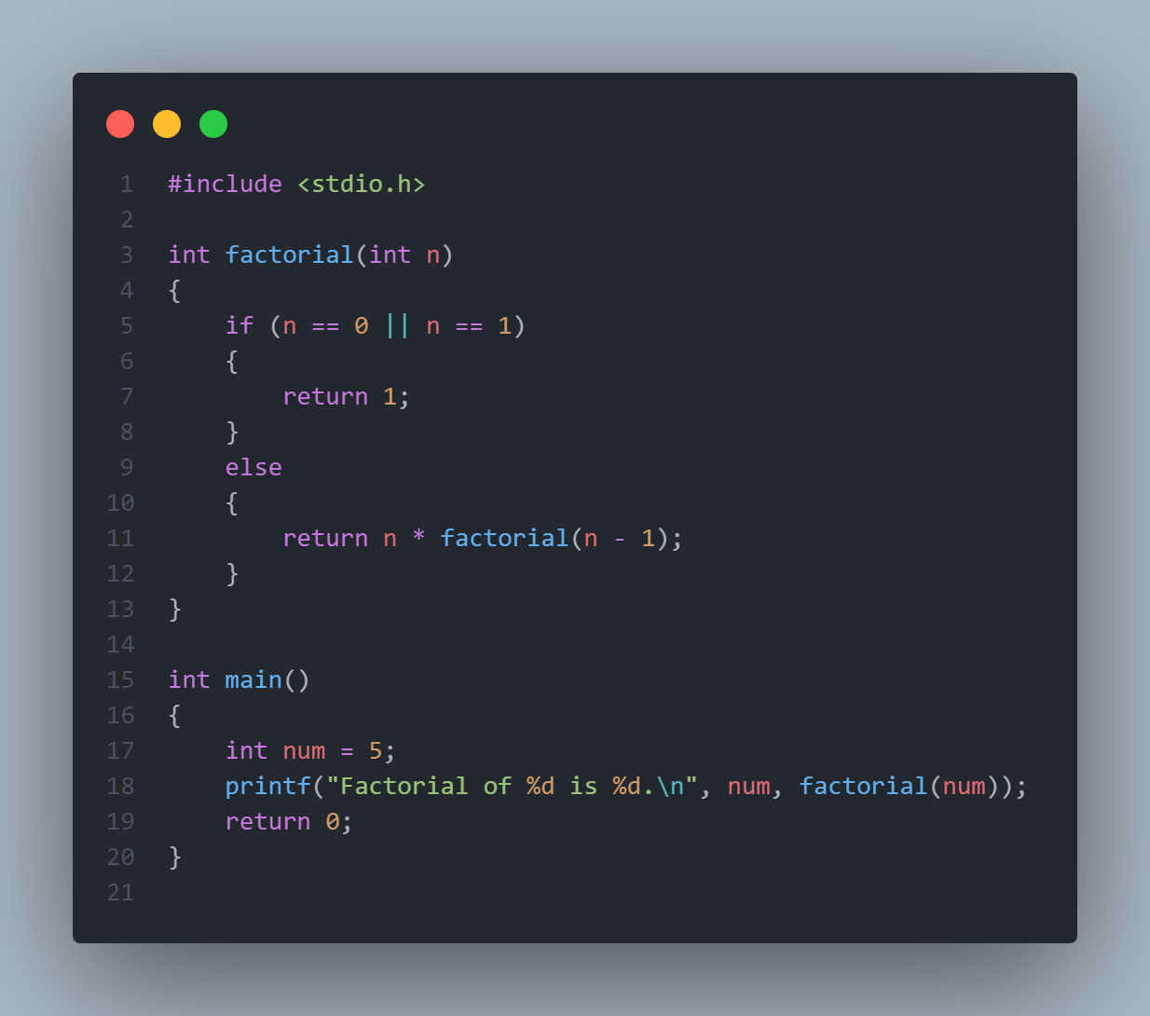

#### Output:

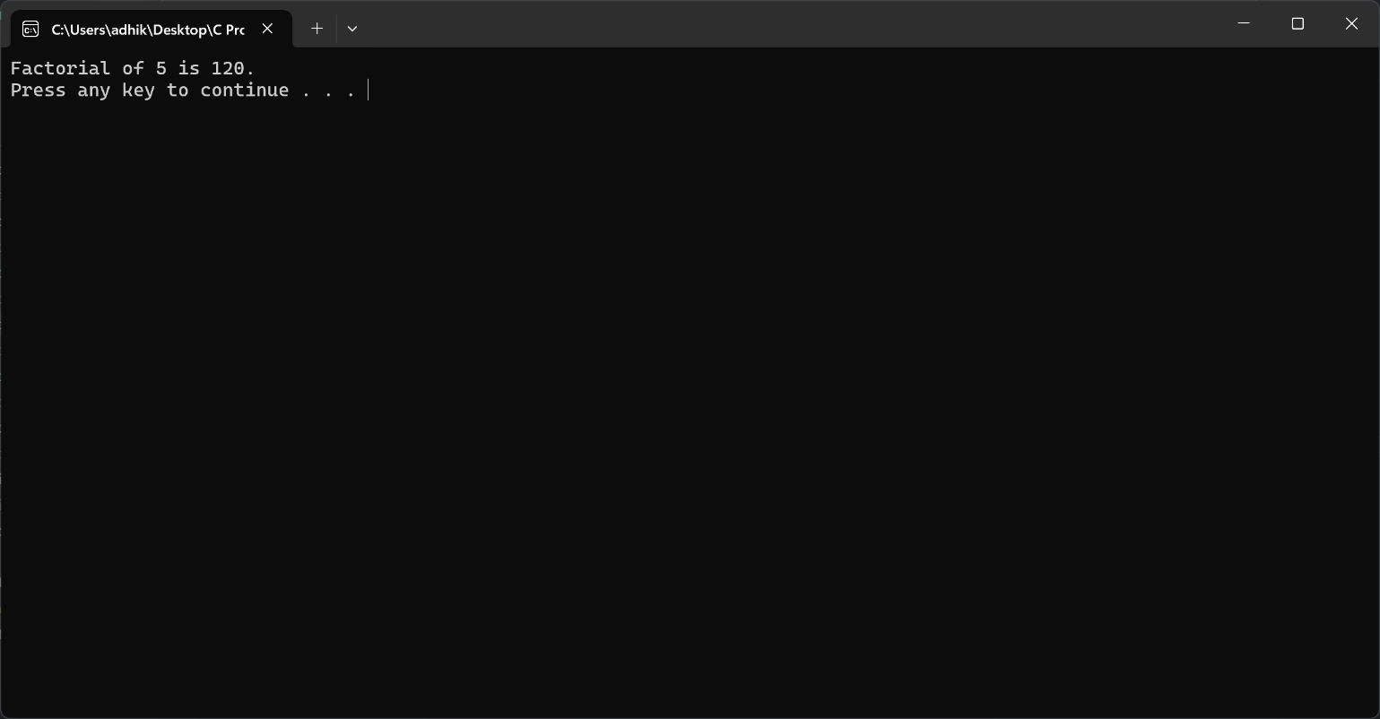

### 2.5 Two Numbers Using the Euclidean Algorithm

#### Code:

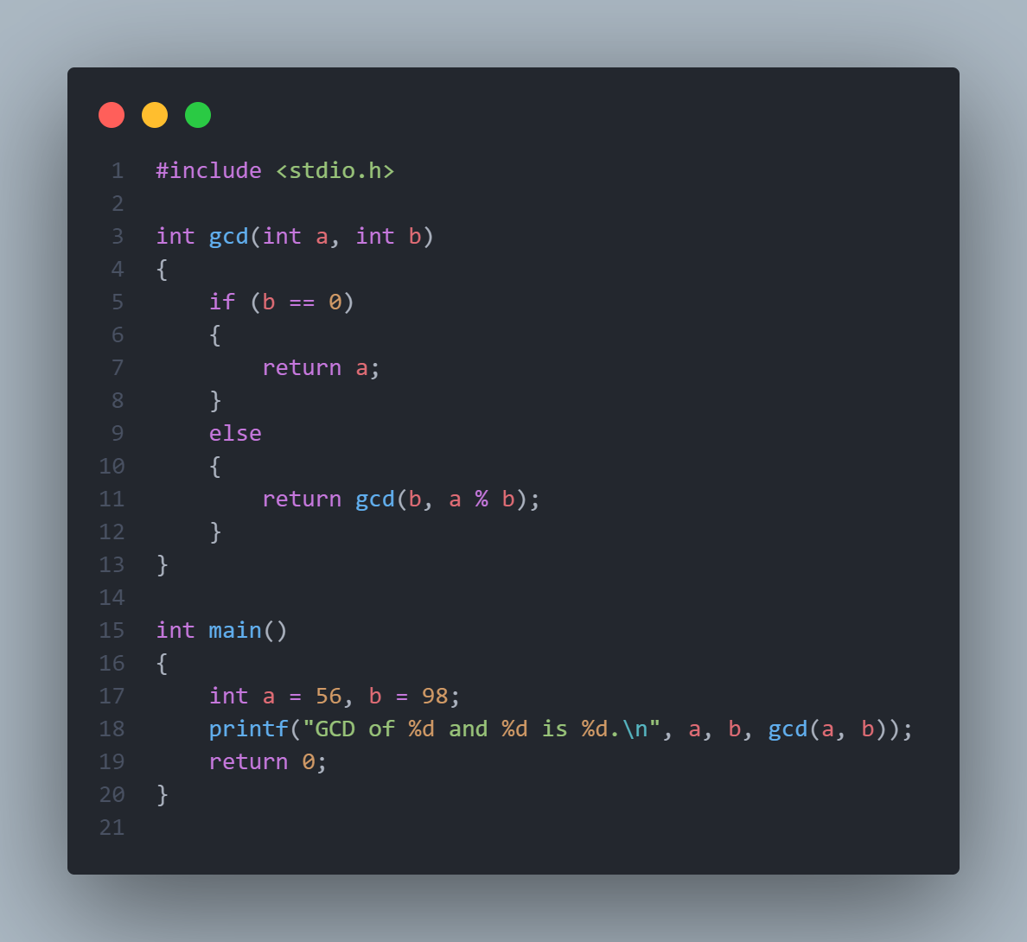

#### Output:

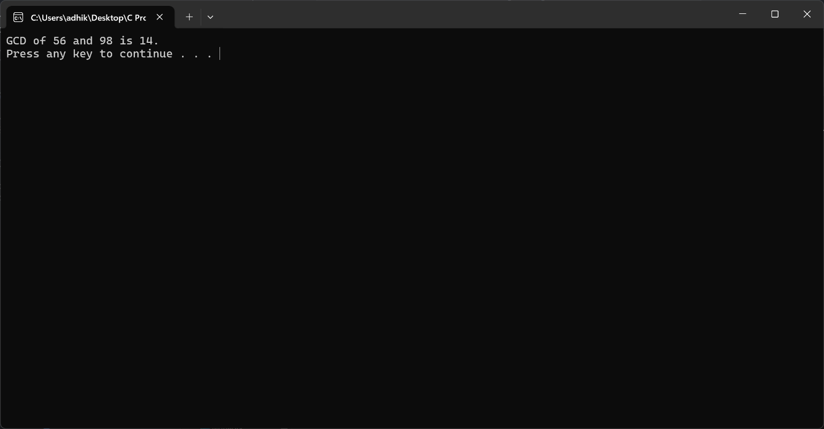

### 2.6 Check if a String is a Palindrome

#### Code:

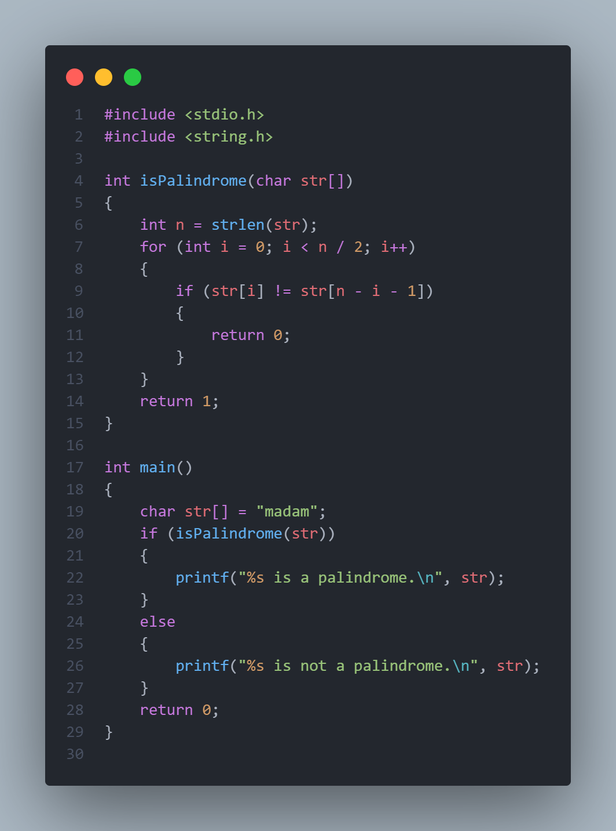

#### Output:

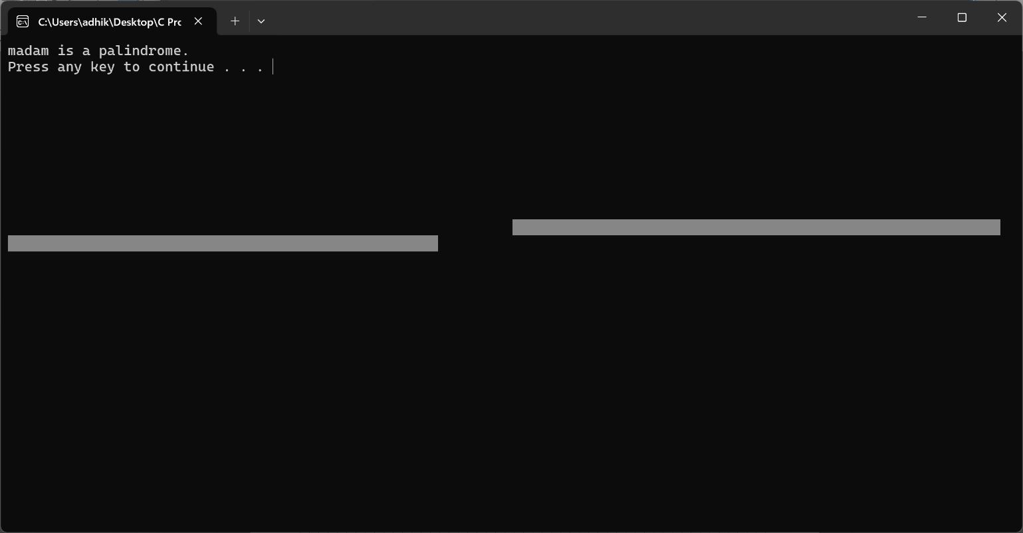

## Conclusion

This document provides a detailed overview of the various C programming exercises, including explanations, code, and instructions for each program. Please refer to the screenshots provided to see the programs in action.

## References

**C Programming Language - K&R**

* *Authors:* Brian W. Kernighan and Dennis M. Ritchie
* *Description:* A seminal book on C programming, providing foundational knowledge and in-depth explanations of C syntax and features.
* *Link:* [The C Programming Language](https://www.amazon.com/C-Programming-Language-Brian-Kernighan/dp/0131103628)

**GNU C Library Documentation**

* *Description:* Official documentation for the GNU C Library, providing detailed information on C standard library functions and their usage.
* *Link:* GNU C Library Documentation

**GeeksforGeeks: C Programming Language**

* *Description:* A comprehensive collection of articles, tutorials, and coding examples for learning C programming concepts and solving problems.
* *Link:* GeeksforGeeks C Programming